

FACULTY OF TECHNOLOGY AND ENGINEERING

**THE MAHARAJA SAYAJIRAO UNIVERSITY, BARODA**

**COMPUTER SCIENCE AND ENGINEERING DEPARTMENT**

**YEAR 2014-2015.**

A PROJECT REPORT ON

**SALES AND INVENTORY**

**MANAGEMENT SYSTEM**

***PROJECT BY:***

1. PATEL NABIL (486)
2. GOR MADHUR (466)

3. JAYSWAL HIREN (467)

***GUIDED BY :***

***1. BHUVAN PAREKH***

***2. ANJALI JIVANI***

***3. P.R BHAVSAR***

**INDEX**

|  |  |
| --- | --- |
| **1** | **PROJECT PROFILE** |
| **2** | **DRAWBACKS OF EXISTING SYSTEM** |
| **3** | **SIMS ADVATAGES OVER EXISTING SYSTEM** |
| **4** | **TECHNOLOGY USED** |
| **5** | **SYSTEM USERS** |
| **6** | **DATA FLOW DIAGRAM** |
| **7** | **ENTITY RELATION DIAGRAM** |
| **8** | **DATABASE DESIGN** |
| **9** | **WORKING OPERATIONS** |
| **10** | **FUTURE EXPACTATIONS** |

***1.PROJECT PROFILE***

This project is aimed at developing an online Sales and Inventory Management System (SIMS) for a departmental store. This system can be used to store the details of the inventory, update the inventory based on the sale details, produce receipts for sales, generate sales and inventory reports periodically etc. This is one integrated system that contains both the user component (used by salespersons, sales managers, inventory managers etc) and the admin component (used by the administrators for performing admin level functions such as adding new items to the inventory, changing the price of an item etc).

***2. DRAWBACKS OF EXISTING SYSTEM***

* In existing system there is no such automatic notification system which informs the inventory manager about the lack of quantity of particular item.
* In existing system there is no “Report generation facility” at Administrator level so that decision making capability increases.
* Sometimes it is difficult to understand working of the system for new user of the system.

***3. SIMS ADVATAGES OVER EXISTING SYSTEM***

* This project is developed for a Sales and Inventory Management System (SIMS) for a departmental store. This system can be used to store the details of the inventory, update the inventory based on the sale details, produce receipts for sales, generate sales and inventory reports periodically etc.
* This is one integrated system that contains both the user component (used by salespersons, sales managers, inventory managers etc) and the admin component (used by the administrators for performing admin level functions such as adding new items to the inventory, changing the price of an item etc).
* Administration level Functionality is improved so that it helps the decision making capabilities of the organization for more efficient output.

***4. TECHNOLOGY USED***

**SOFTWARE USED:**

1. Language : C#.NET

2. Technologies : Microsoft.NET,

ASP.NET, ADO.NET

3. Database : MS SQL SERVER 2008

4. IDE : Visual Studio 2010

5. O.S : MW7 or Later Version

**HARDWARE USED:**

* + - 1. Processor : INTEL CORE i5
      2. Hard Disk : 500GB
      3. RAM : 4GB

***1. C#.NET***

* C# (pronounced as see sharp) is a [multi-paradigm programming language](http://en.wikipedia.org/wiki/Multi-paradigm_programming_language) encompassing [strong typing](http://en.wikipedia.org/wiki/Strong_typing), [imperative](http://en.wikipedia.org/wiki/Imperative_programming),[declarative](http://en.wikipedia.org/wiki/Declarative_programming), [functional](http://en.wikipedia.org/wiki/Functional_programming), [generic](http://en.wikipedia.org/wiki/Generic_programming), [object-oriented](http://en.wikipedia.org/wiki/Object-oriented_programming) ([class](http://en.wikipedia.org/wiki/Class_(computer_science))-based), and [component-oriented](http://en.wikipedia.org/wiki/Component-based_software_engineering) programming disciplines.
* It was developed by [Microsoft](http://en.wikipedia.org/wiki/Microsoft) within its [.NET](http://en.wikipedia.org/wiki/.NET_Framework) initiative and later approved as a standard by [Ecma](http://en.wikipedia.org/wiki/Ecma_International) (ECMA-334) and [ISO](http://en.wikipedia.org/wiki/International_Organization_for_Standardization) (ISO/IEC 23270:2006). C# is one of the programming languages designed for the [Common Language Infrastructure](http://en.wikipedia.org/wiki/Common_Language_Infrastructure).
* C# is intended to be a simple, modern, general-purpose, object-oriented programming language.

***2. Microsoft.NET,***

* .NET (pronounced *dotnet*) is a [software framework](http://en.wikipedia.org/wiki/Software_framework) developed by [Microsoft](http://en.wikipedia.org/wiki/Microsoft) that runs primarily on [Microsoft Windows](http://en.wikipedia.org/wiki/Microsoft_Windows).
* It includes a large [class library](http://en.wikipedia.org/wiki/Class_library) known as [Framework Class Library](http://en.wikipedia.org/wiki/Framework_Class_Library) (FCL) and provides [language interoperability](http://en.wikipedia.org/wiki/Language_interoperability)(each language can use code written in other languages) across several [programming languages](http://en.wikipedia.org/wiki/Programming_language).
* Programs written for .NET Framework execute in a [software](http://en.wikipedia.org/wiki/Software) environment (as contrasted to [hardware](http://en.wikipedia.org/wiki/Computer_hardware) environment), known as [Common Language Runtime](http://en.wikipedia.org/wiki/Common_Language_Runtime) (CLR), an [application virtual machine](http://en.wikipedia.org/wiki/Process_virtual_machine) that provides services such as security, [memory management](http://en.wikipedia.org/wiki/Memory_management), and [exception handling](http://en.wikipedia.org/wiki/Exception_handling). FCL and CLR together constitute .NET Framework.
* FCL provides [user interface](http://en.wikipedia.org/wiki/User_interface), [data access](http://en.wikipedia.org/wiki/Data_access), [databaseconnectivity](http://en.wikipedia.org/wiki/Database_connection), [cryptography](http://en.wikipedia.org/wiki/Cryptography), [web application](http://en.wikipedia.org/wiki/Web_application) development, numeric [algorithms](http://en.wikipedia.org/wiki/Algorithm), and [network communications](http://en.wikipedia.org/wiki/Computer_networking).
* Programmers produce software by combining their own [source code](http://en.wikipedia.org/wiki/Source_code) with .NET Framework and other libraries. .NET Framework is intended to be used by most new applications created for Windows platform. Microsoft also produces an [integrated development environment](http://en.wikipedia.org/wiki/Integrated_development_environment) largely for .NET software called [Visual Studio](http://en.wikipedia.org/wiki/Microsoft_Visual_Studio).

***3. Database : MS SQL SERVER 2008***

* SQL Server 2008 (formerly codenamed "Katmai") was released on August 6, 2008 and aims to make data management [self-tuning](http://en.wikipedia.org/wiki/Self-tuning), self organizing, and self maintaining with the development of *SQL Server Always On* technologies, to provide near-zero downtime.
* SQL Server 2008 also includes support for [structured](http://en.wikipedia.org/wiki/Structured_data) and semi-structured data, including digital media formats for pictures, audio, video and other multimedia data. In current versions, such multimedia data can be stored as [BLOBs](http://en.wikipedia.org/wiki/Binary_large_object) (binary large objects), but they are generic bitstreams.
* Intrinsic awareness of multimedia data will allow specialized functions to be performed on them. SQL Server 2008 can be a data storage backend for *different varieties of data: XML, email, time/calendar, file, document, spatial, etc.* as well as perform *search, query, analysis, sharing, and synchronization* across all data types.

***4. IDE : Visual Studio 2010***

* **Microsoft Visual Studio** is an [integrated development environment](http://en.wikipedia.org/wiki/Integrated_development_environment) (IDE) from [Microsoft](http://en.wikipedia.org/wiki/Microsoft).
* It is used to develop [computer programs](http://en.wikipedia.org/wiki/Computer_program) for [Microsoft Windows](http://en.wikipedia.org/wiki/Microsoft_Windows), as well as [web sites](http://en.wikipedia.org/wiki/Web_site), [web applications](http://en.wikipedia.org/wiki/Web_application) and [web services](http://en.wikipedia.org/wiki/Web_service).
* Visual Studio uses Microsoft software development platforms such as [Windows API](http://en.wikipedia.org/wiki/Windows_API), [Windows Forms](http://en.wikipedia.org/wiki/Windows_Forms), [Windows Presentation Foundation](http://en.wikipedia.org/wiki/Windows_Presentation_Foundation), [Windows Store](http://en.wikipedia.org/wiki/Windows_Store)and [Microsoft Silverlight](http://en.wikipedia.org/wiki/Microsoft_Silverlight).
* It can produce both [native code](http://en.wikipedia.org/wiki/Native_code) and [managed code](http://en.wikipedia.org/wiki/Managed_code).
* The Visual Studio 2010 [IDE](http://en.wikipedia.org/wiki/Integrated_development_environment) was redesigned which, according to [Microsoft](http://en.wikipedia.org/wiki/Microsoft), clears the UI organization and "reduces clutter and complexity."
* The new IDE better supports multiple document windows and floating tool windows, while offering better multi-monitor support.
* The IDE shell has been rewritten using the [Windows Presentation Foundation](http://en.wikipedia.org/wiki/Windows_Presentation_Foundation) (WPF), whereas the internals have been redesigned using [Managed Extensibility Framework](http://en.wikipedia.org/wiki/Managed_Extensibility_Framework) (MEF) that offers more extensibility points than previous versions of the IDE that enabled add-ins to modify the behavior of the IDE.
* Visual Studio 2010 comes with [.NET Framework 4](http://en.wikipedia.org/wiki/.NET_Framework_4) and supports developing applications targeting [Windows 7](http://en.wikipedia.org/wiki/Windows_7). It supports [IBM DB2](http://en.wikipedia.org/wiki/IBM_DB2) and [Oracle](http://en.wikipedia.org/wiki/Oracle_Database) databases, in addition to [Microsoft SQL Server](http://en.wikipedia.org/wiki/Microsoft_SQL_Server).

***5.WPF***

* **Windows Presentation Foundation** (or **WPF**) is a graphical subsystem for rendering user interfaces in Windows-based applications by [Microsoft](http://en.wikipedia.org/wiki/Microsoft). WPF, previously known as "Avalon", was initially released as part of [.NET Framework 3.0](http://en.wikipedia.org/wiki/.NET_Framework_3.0). Rather than relying on the older [GDI](http://en.wikipedia.org/wiki/Graphics_Device_Interface) subsystem, WPF uses [DirectX](http://en.wikipedia.org/wiki/DirectX).
* WPF attempts to provide a consistent programming model for building applications and separates the user interface from [business logic](http://en.wikipedia.org/wiki/Business_logic). It resembles similar [XML](http://en.wikipedia.org/wiki/XML)-oriented [object models](http://en.wikipedia.org/wiki/Object_model), such as those implemented in [XUL](http://en.wikipedia.org/wiki/XUL) and [SVG](http://en.wikipedia.org/wiki/SVG).
* WPF employs [XAML](http://en.wikipedia.org/wiki/Extensible_Application_Markup_Language), an [XML](http://en.wikipedia.org/wiki/XML)-based language, to define and link various interface elements. WPF applications can also be deployed as standalone desktop programs, or hosted as an embedded object in a website.
* WPF aims to unify a number of common [user interface](http://en.wikipedia.org/wiki/User_interface) elements, such as 2D/3D rendering, fixed and adaptive [documents](http://en.wikipedia.org/wiki/Document_file_format), [typography](http://en.wikipedia.org/wiki/Typography), [vector graphics](http://en.wikipedia.org/wiki/Vector_graphics), runtime [animation](http://en.wikipedia.org/wiki/Animation), and pre-rendered media. These elements can then be linked and manipulated based on various events, user interactions, and [data bindings](http://en.wikipedia.org/wiki/XML_data_binding).

1. ***SYSTEM USERS***

* The SIMS has the following system users

1. Sales Manager

2.Sales Person

3.Inventory Manager

4. Admin

* + - * 1. ***Sales manager***

The **sales manager** is able to

* login to the system/change his password after logging in etc
* check how many bills have been generated in the day so far
* check how much money is transacted in the day so far
* check how many items have been returned so far in the day
* check for any exception reports from the sales persons and correct it by contacting the inventory manager
* generate sales-trend graphs for each of the item (like how is apple selling in the last one month)

***2.Sales Person***

A **sales person** is able to

* + login to the system through the initial screen of the system
  + change the password after logging into the system
  + see the status of the inventory, ie, whether a particular item is available or not etc
  + Search for a particular item by typing the Item name and Item no.
  + enter the items purchased by a customer and produce a bill for the same (the bill will have a unique sale id, date, time, item/quantity/price details etc)
  + cancel the produced bill, in case of error in entering the details, and produce a new one
  + take back an already sold item that is not satisfactory to the customer (the shop allows that) and produce a receipt for the same
  + inform the inventory manager about the items that are not available, so that they can be stocked
  + inform the sales manager about any exceptions (such as an item is being purchased, but it is not available in the system)
  + get help about the system on how to use the different features of the system

***3.INVENTORY MANAGER***

The **inventory manager** should be able to

* login to the system/change his password after logging in etc
* check the status of the inventory
* see the reports from sales people about items that are not available and need to be kept in the inventory
* validate the inventory against the sales done in the previous day (whether the items that are sold and the change in the inventory for the corresponding items match etc)
* generate inventory reports of the items category-wise, price-wise etc
* generate inventory-trends (like how is coffee powder stock changing over the month).

***4.Admin***

The **administrator** is able to

* + login to the system and change his password after logging in
  + add new users to the system
  + add new items/categories to the inventory (‘grape’ may be added to the category ‘fruits’ or a new category such as ‘vegetables’ may be added) change the price of an item
  + Add suppliers to the inventory.

***8.DATABASE DESIGN***

*ALL TABLES*

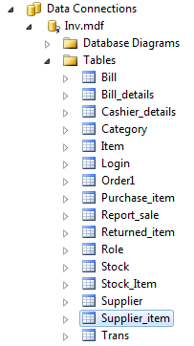

*TABLE LOGIN*

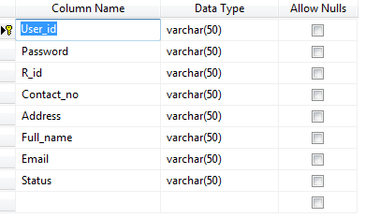

*TABLE ITEM*

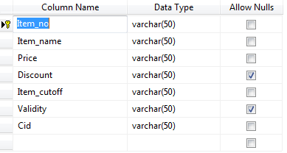

*TABLE BILL DETAILS*

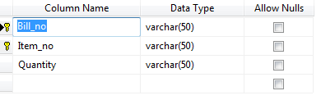

*TABLE BILL*

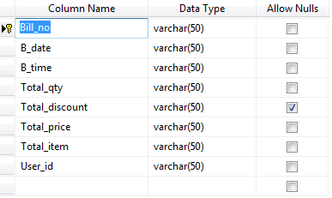

*TABLE CASHIER DETAILS*

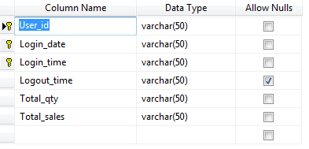

*TABLE REPORT SALE*

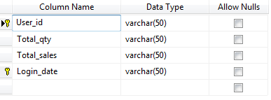

*TABLE CATEGORY*

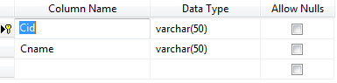

*TABLE ROLE*

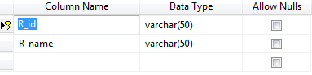

*TABLE STOCK*

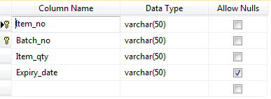

*TABLE STOCK ITEM*

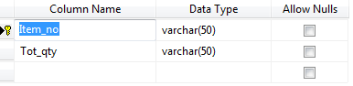

*TABLE ORDER*

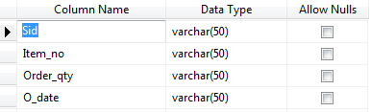

*TABLE PURCHASE ITEM*

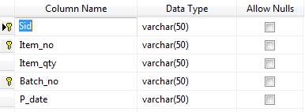

*TABLE RETURN ITEM*

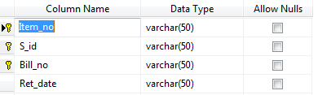

*TABLE SUPPLIER*

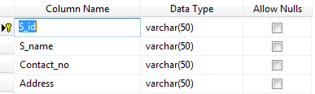

*TABLE SUPPLIER ITEM*

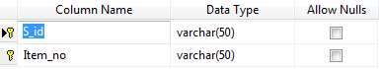

***9.WORKING OPERATIONS***

*LOGIN PAGE AND ITS VALIDATION*

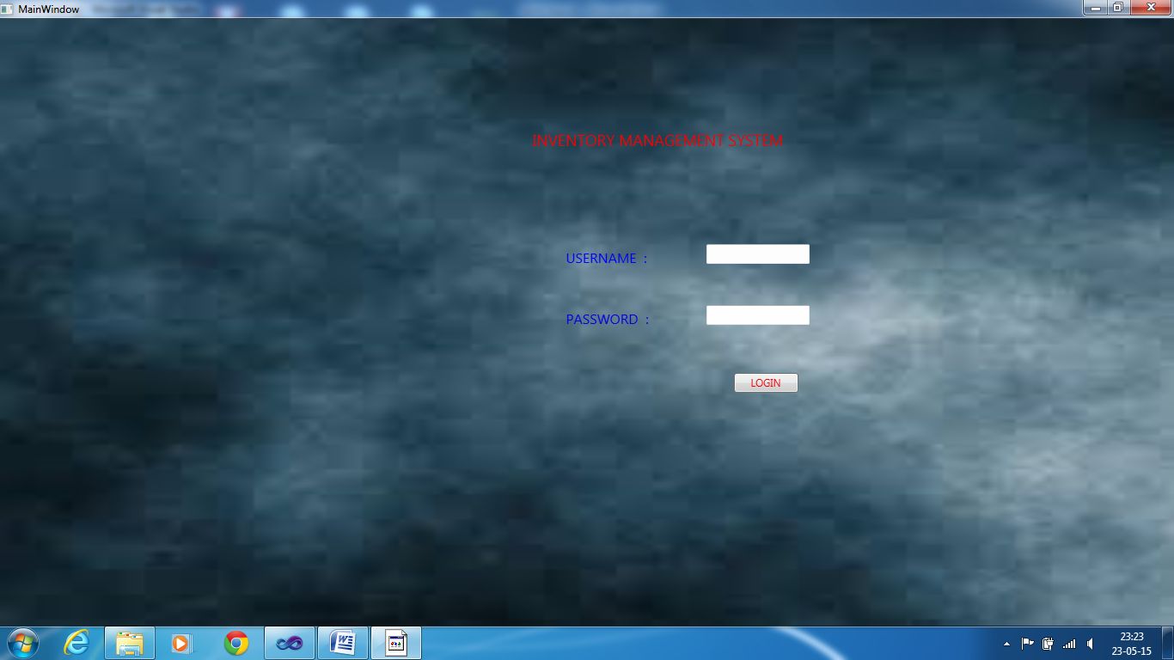

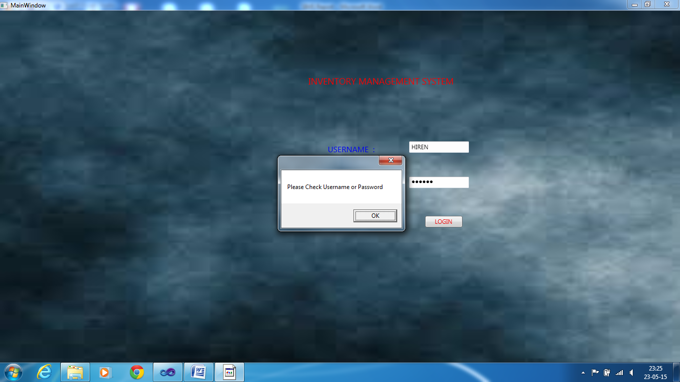

*ADMIN PAGE AND ITS SUBPAGES AND ITS VALIDATIONS*

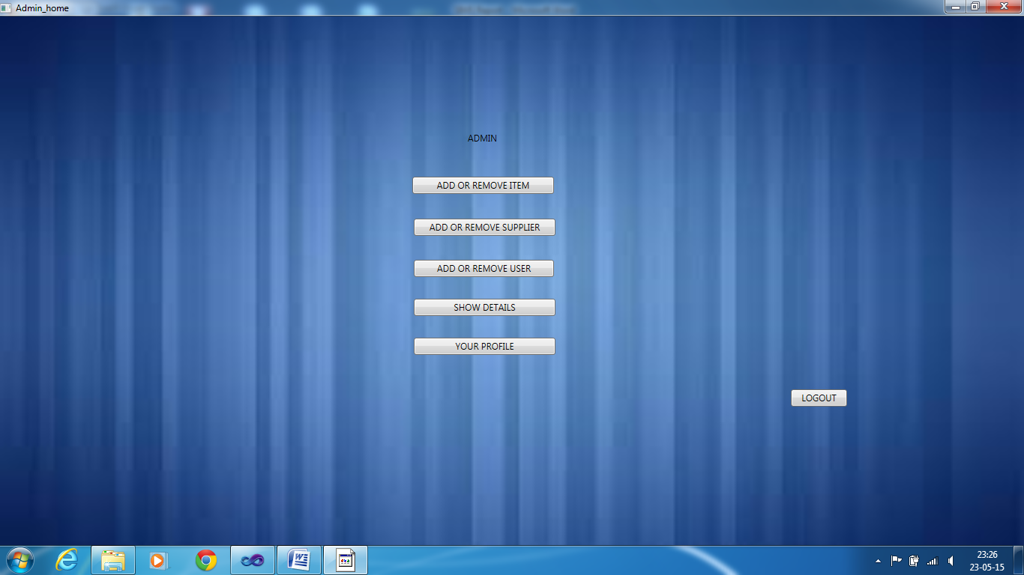

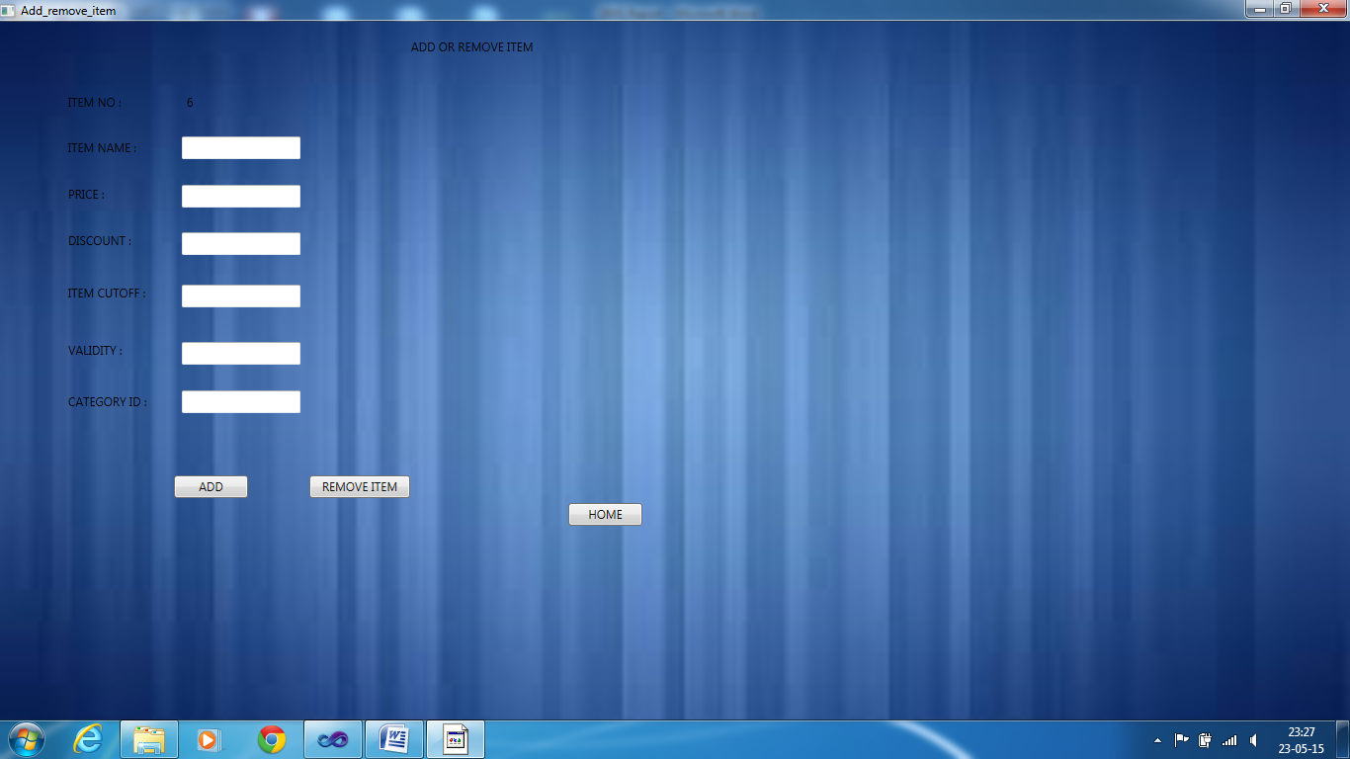

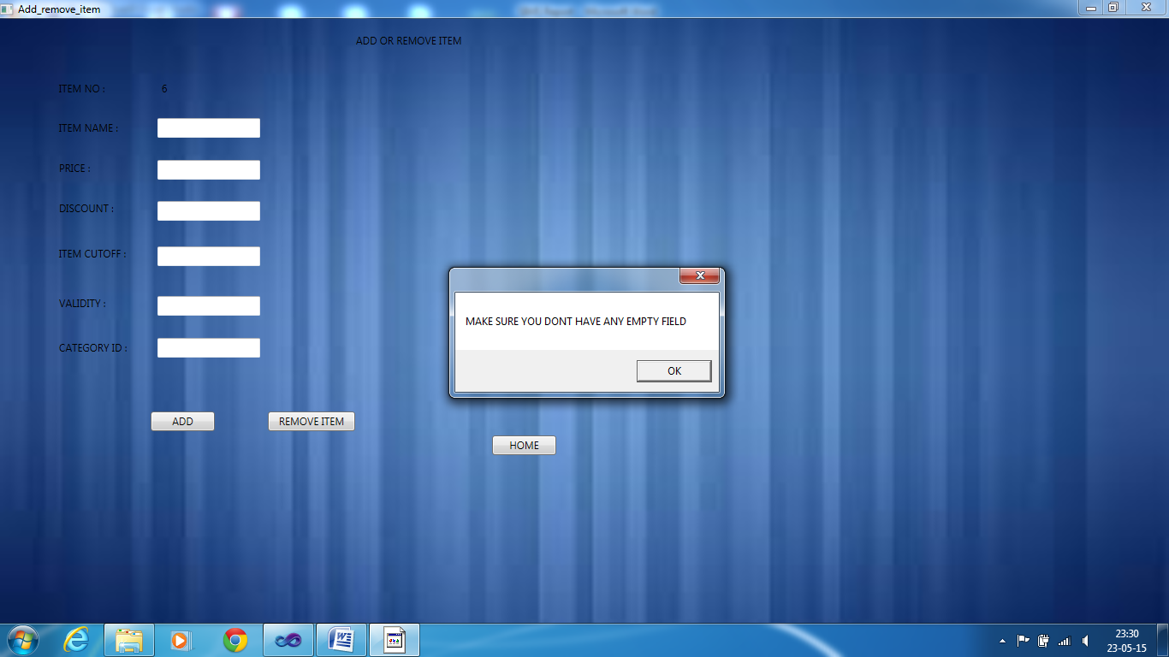

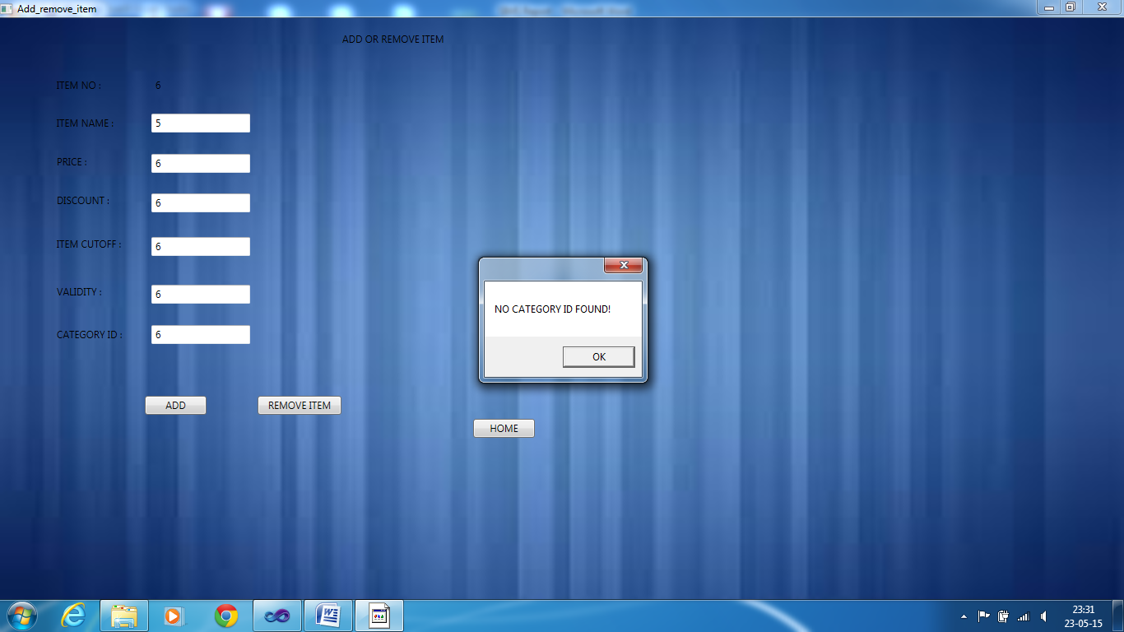

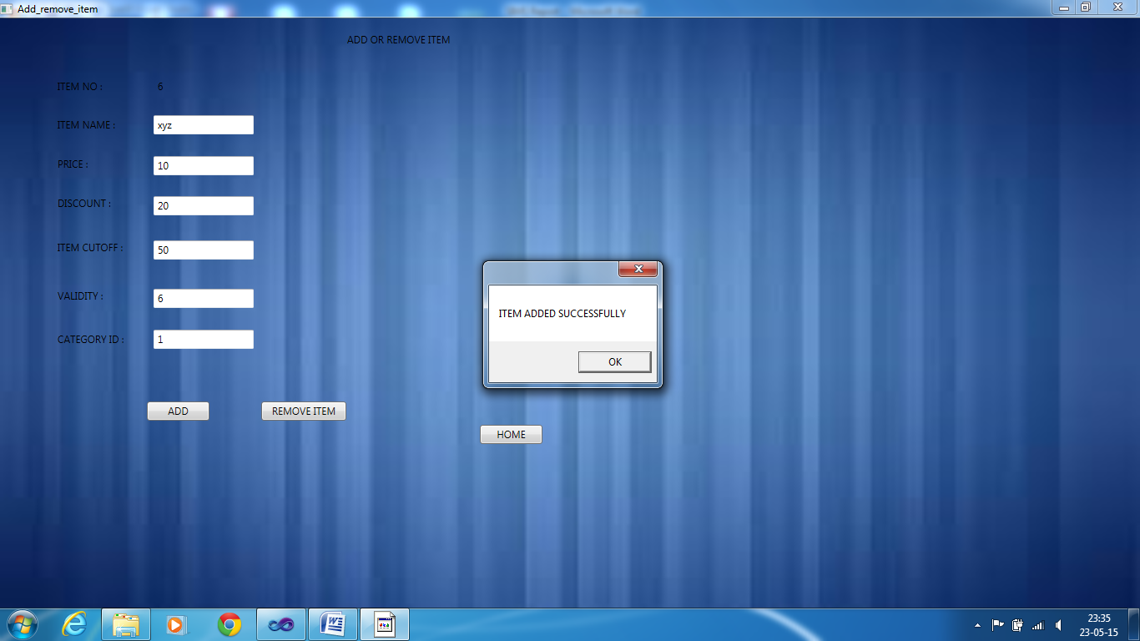

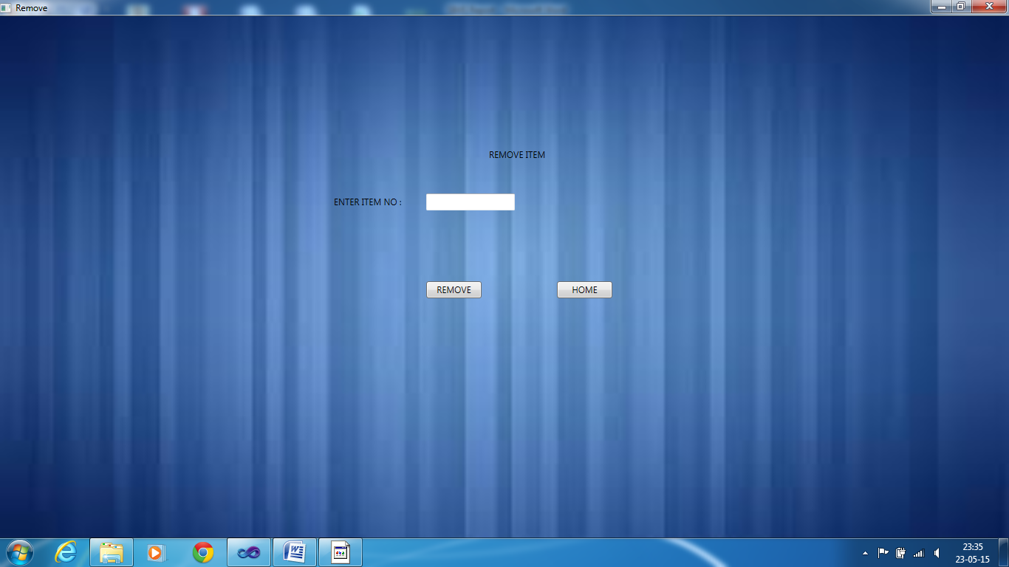

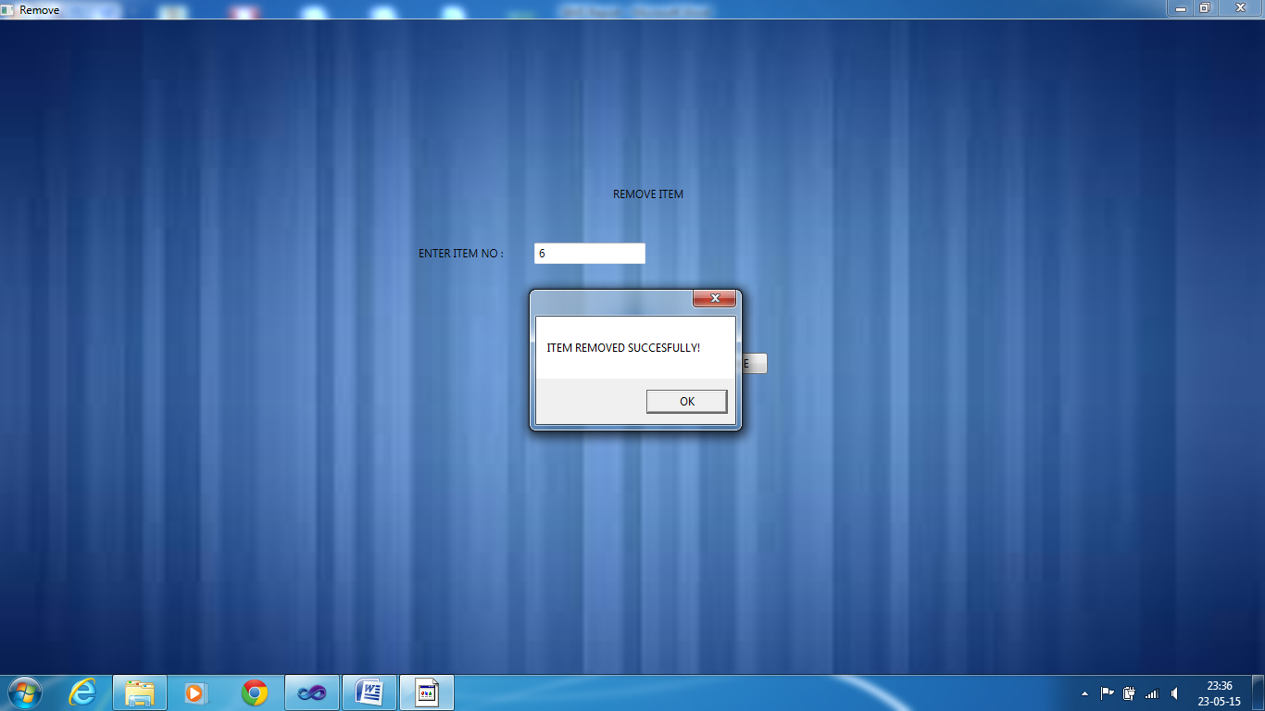

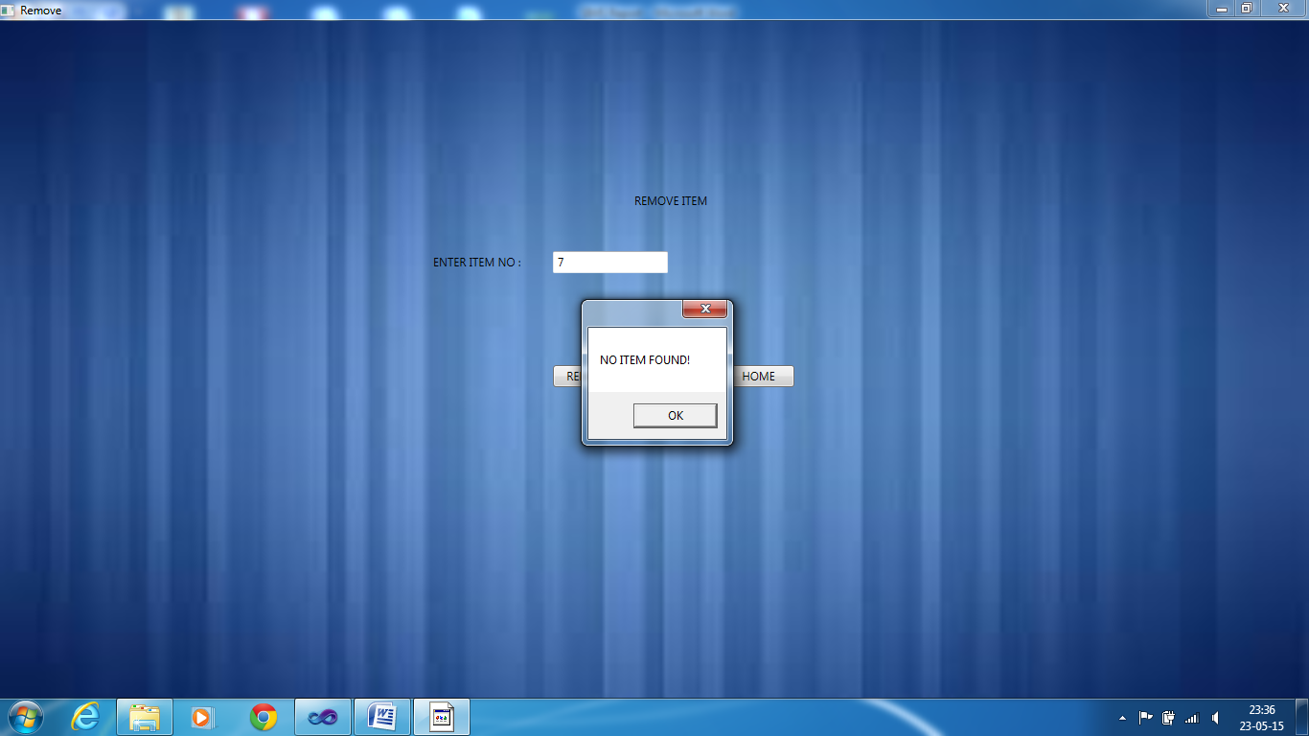

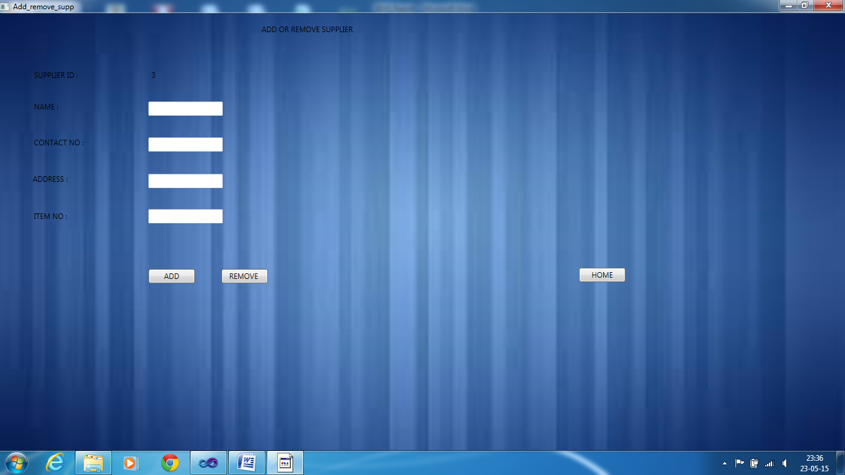

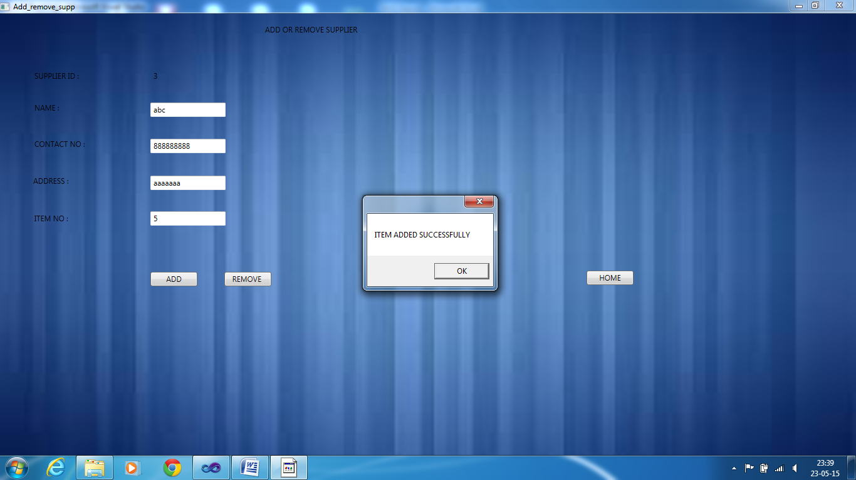

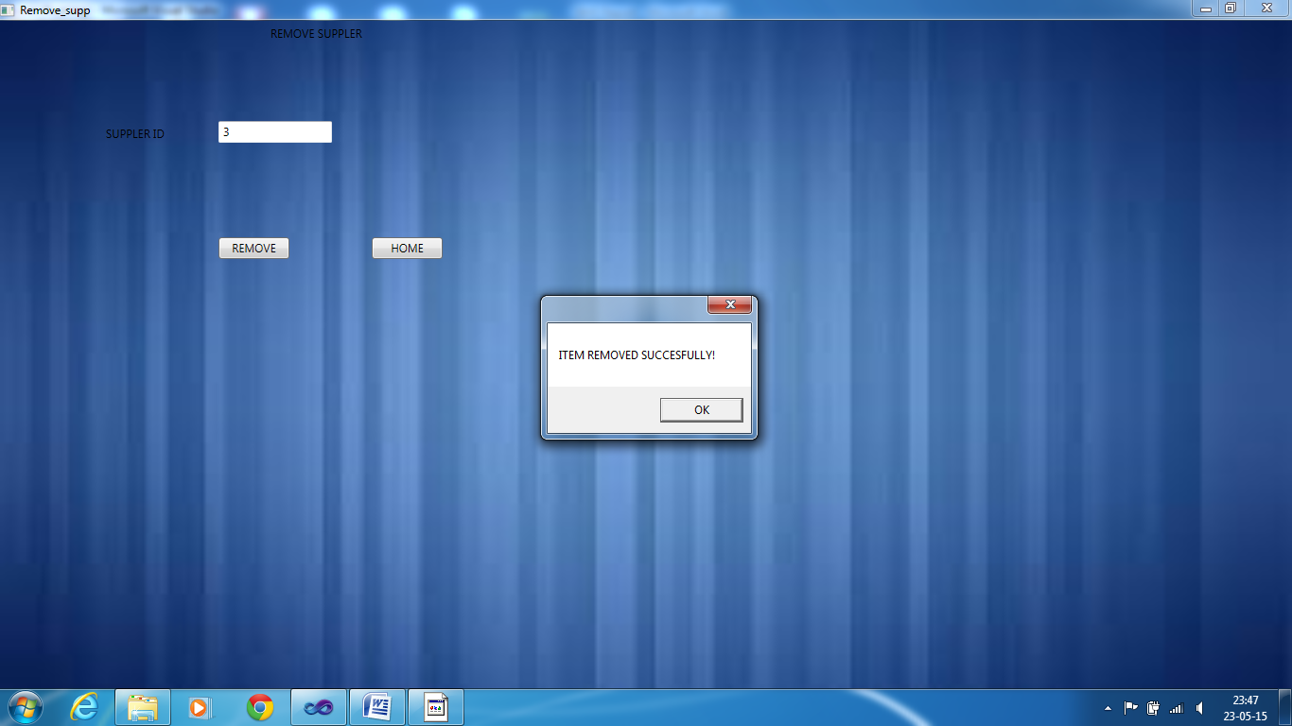

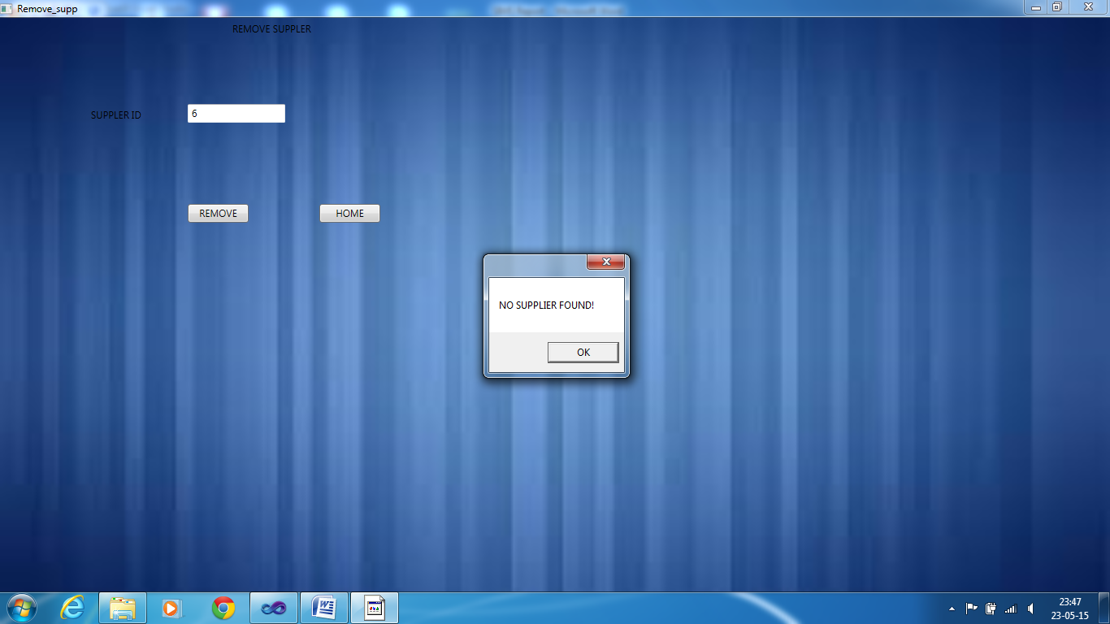

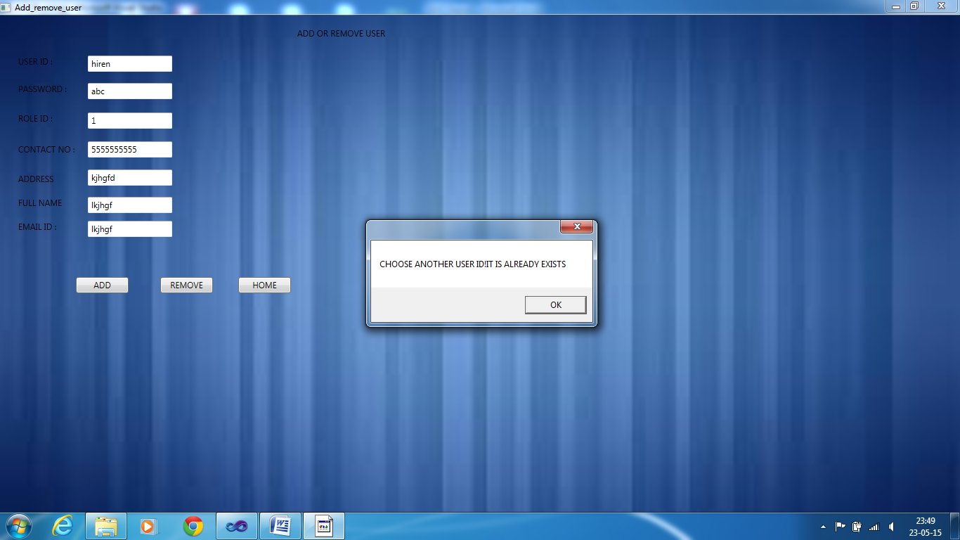

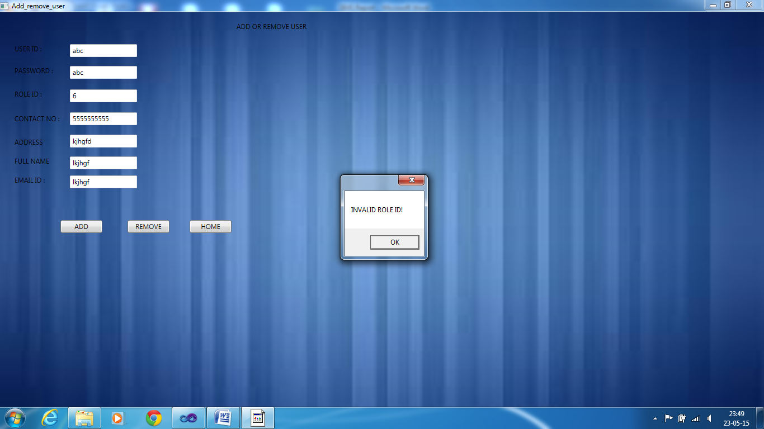

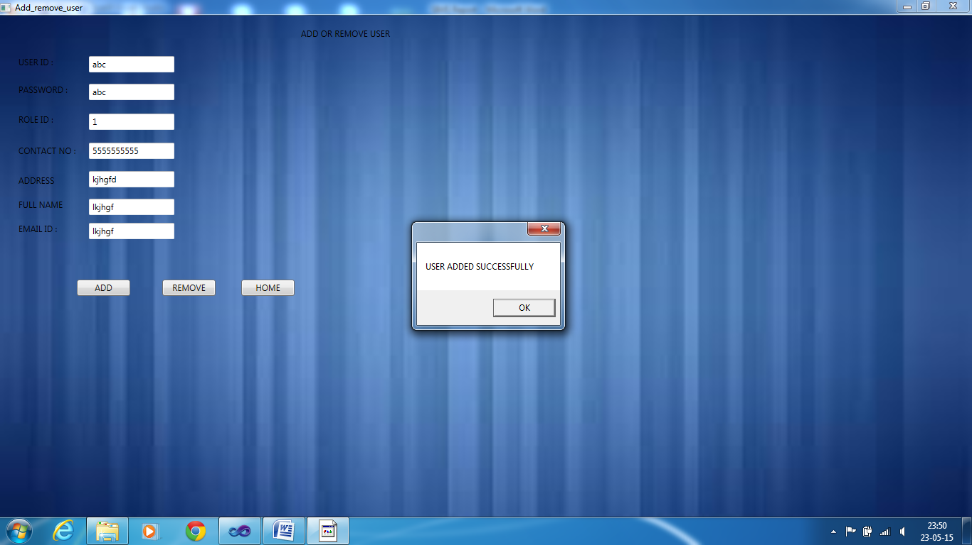

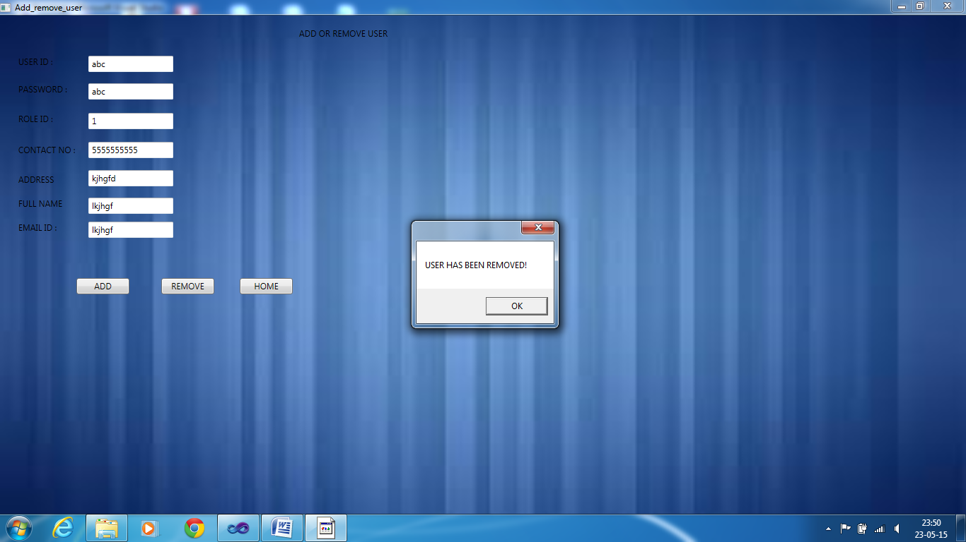

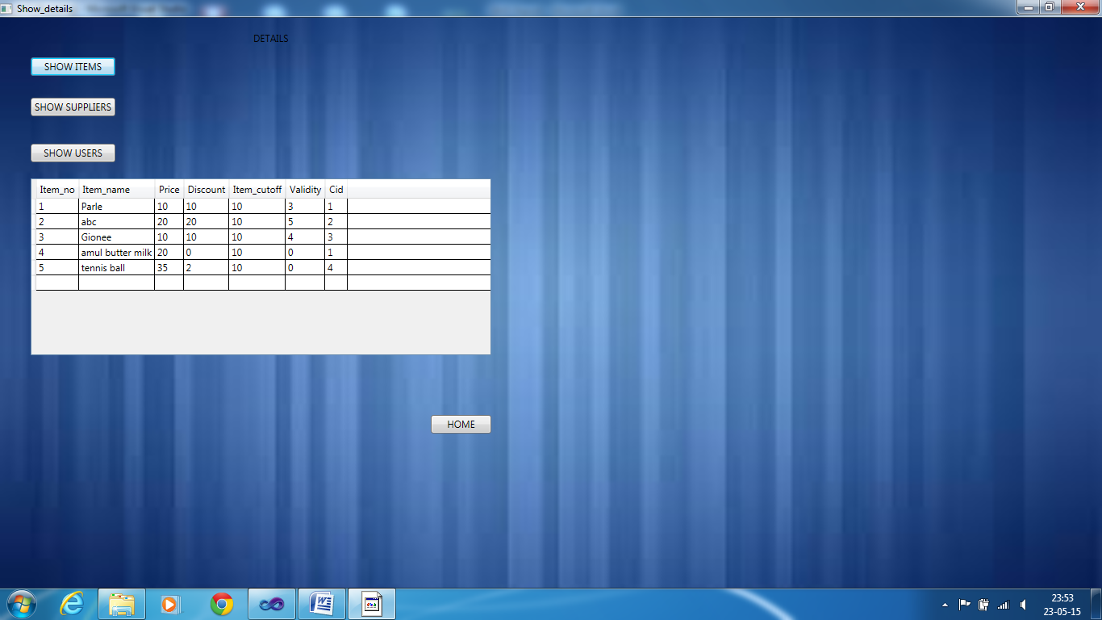

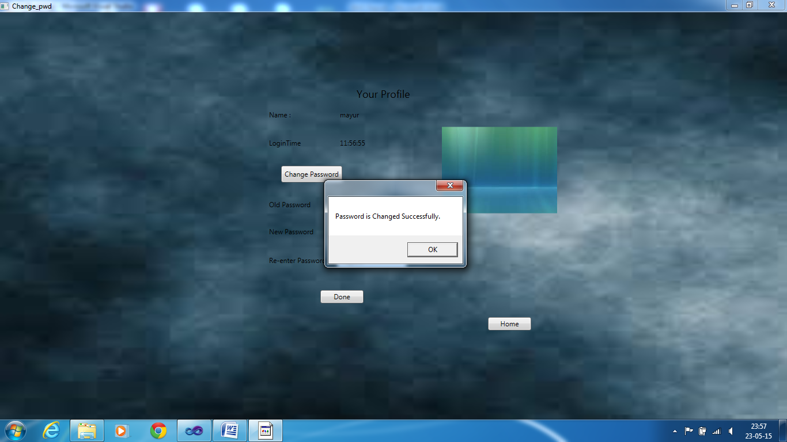

*INVENTORY MANAGER ITS SUBPAGES AND ITS VALIDATION*

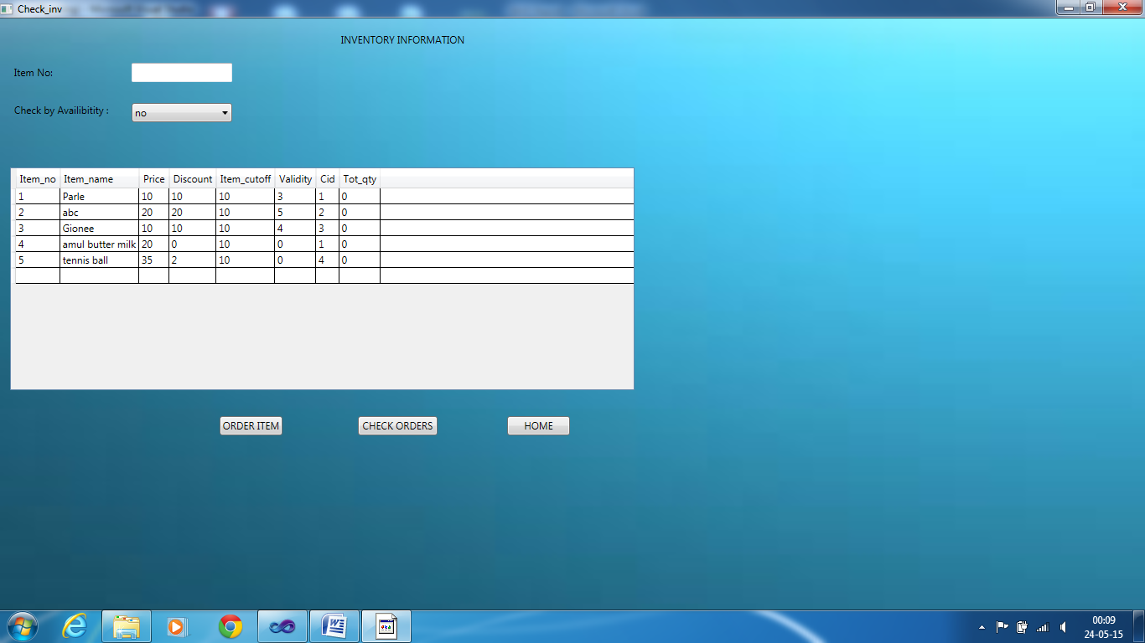

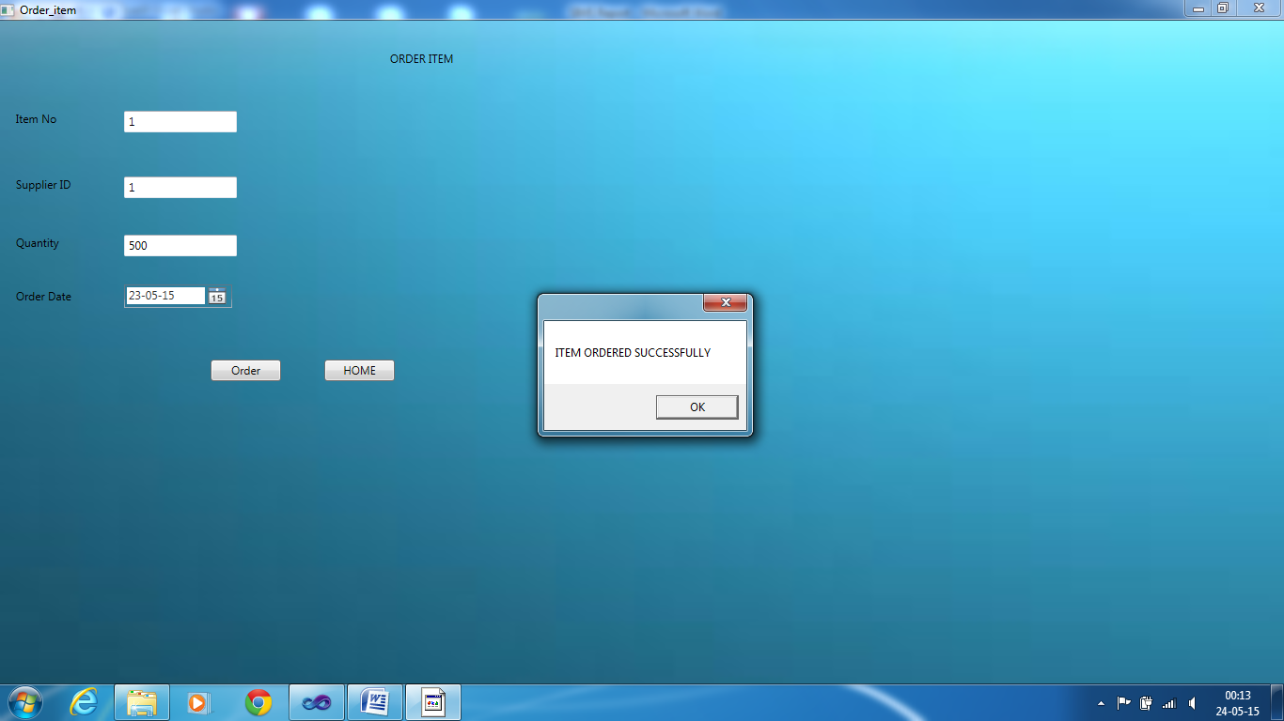

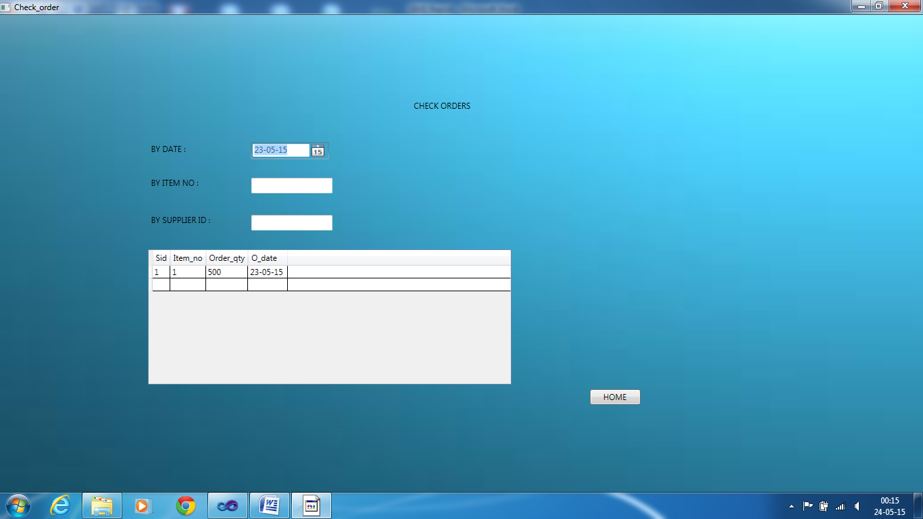

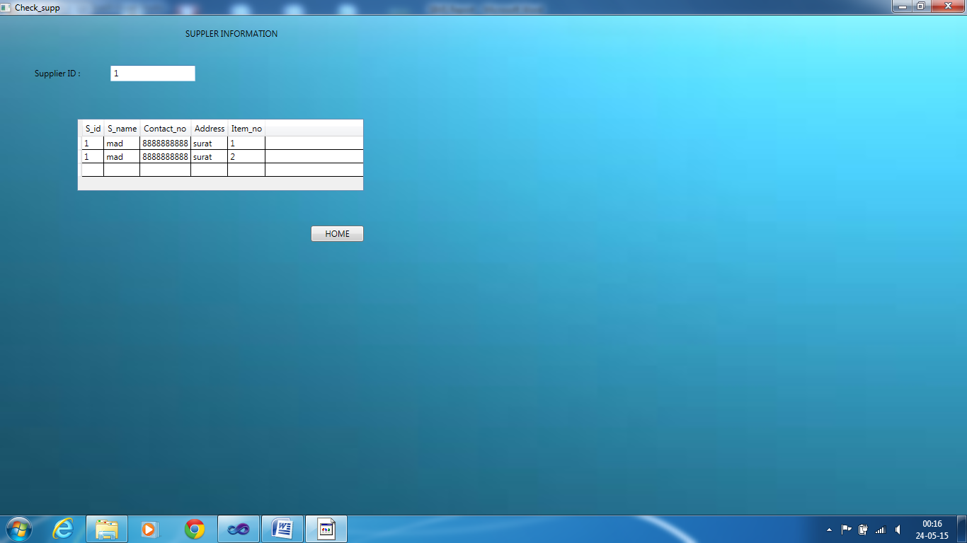

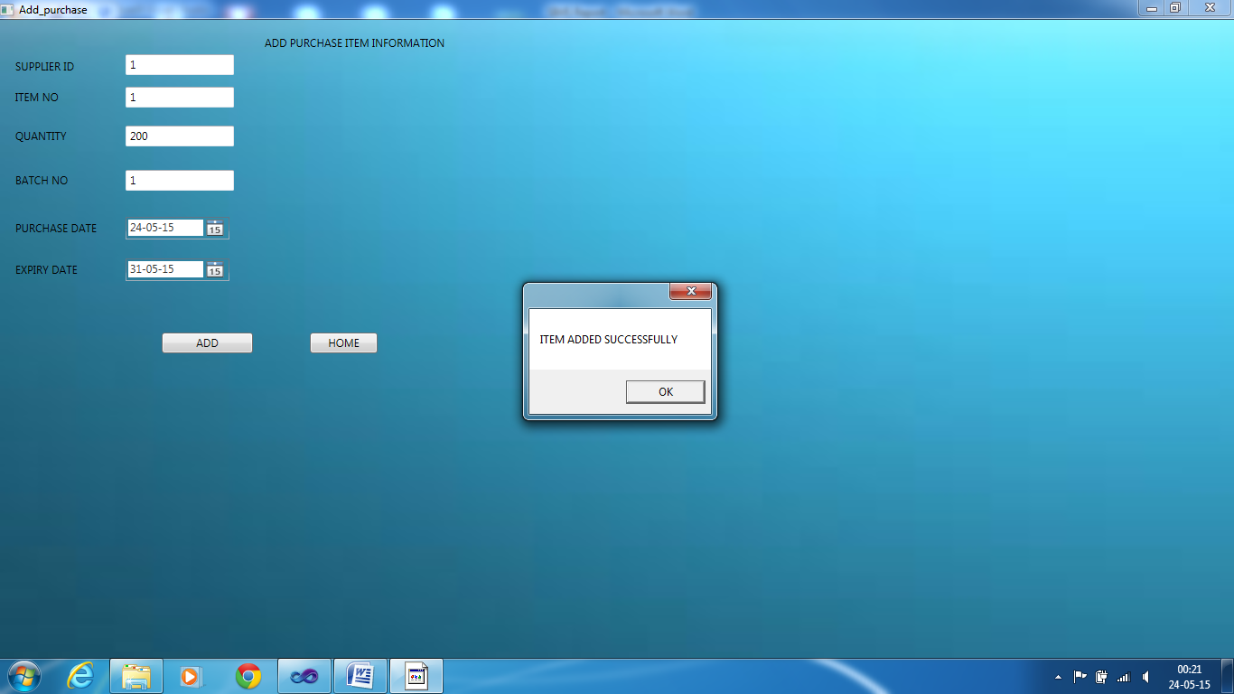

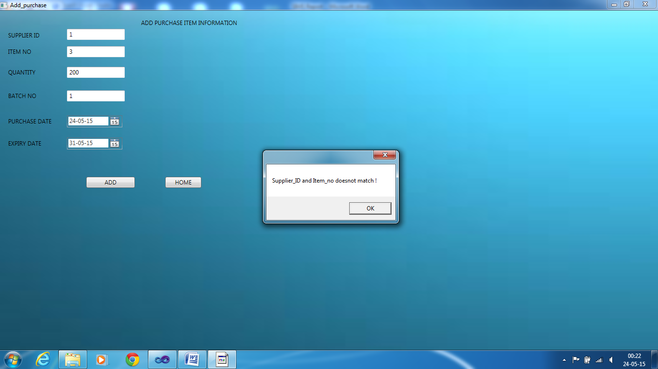

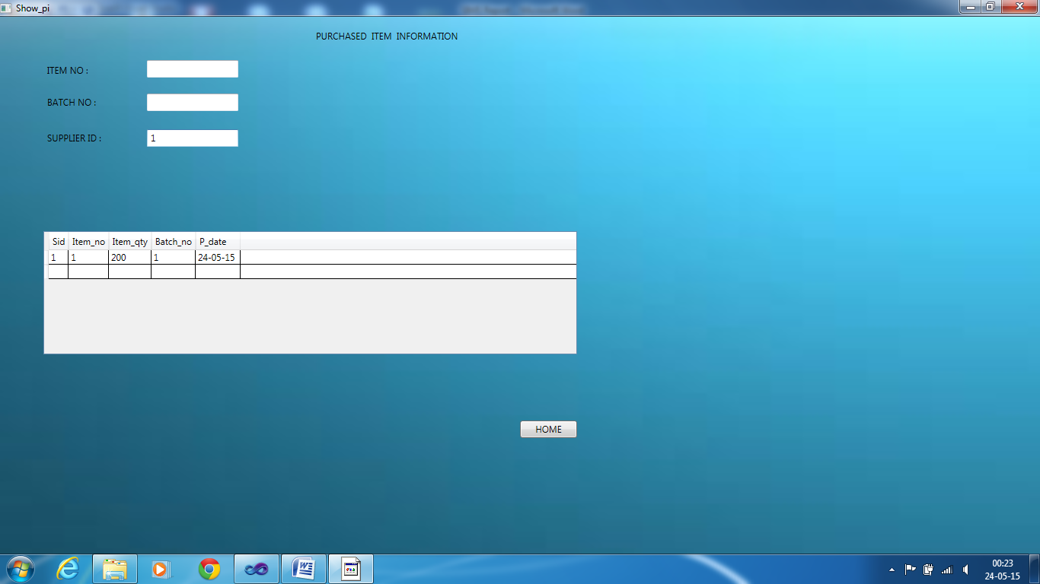

*SALES PERSON ITS SUBPAGES AND ITS VALIDATION*

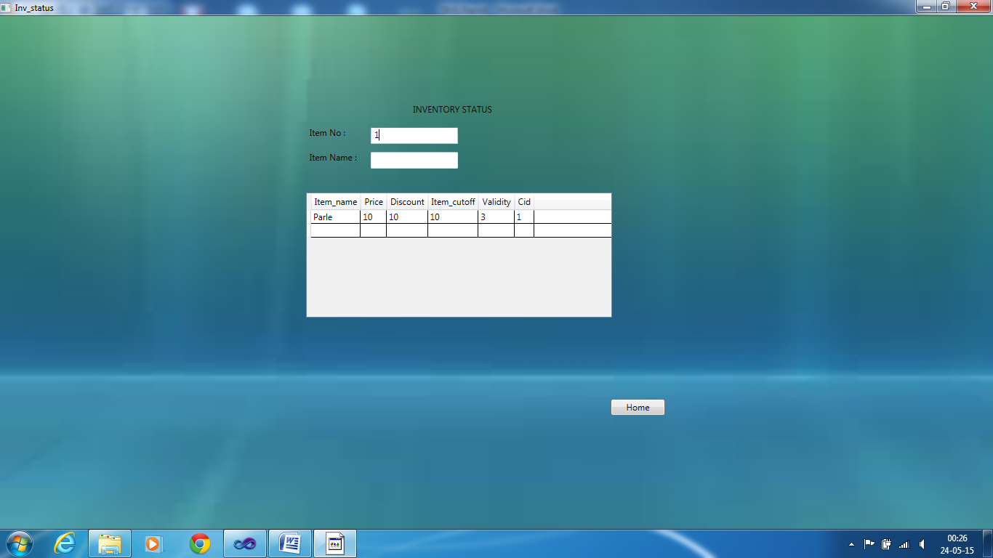

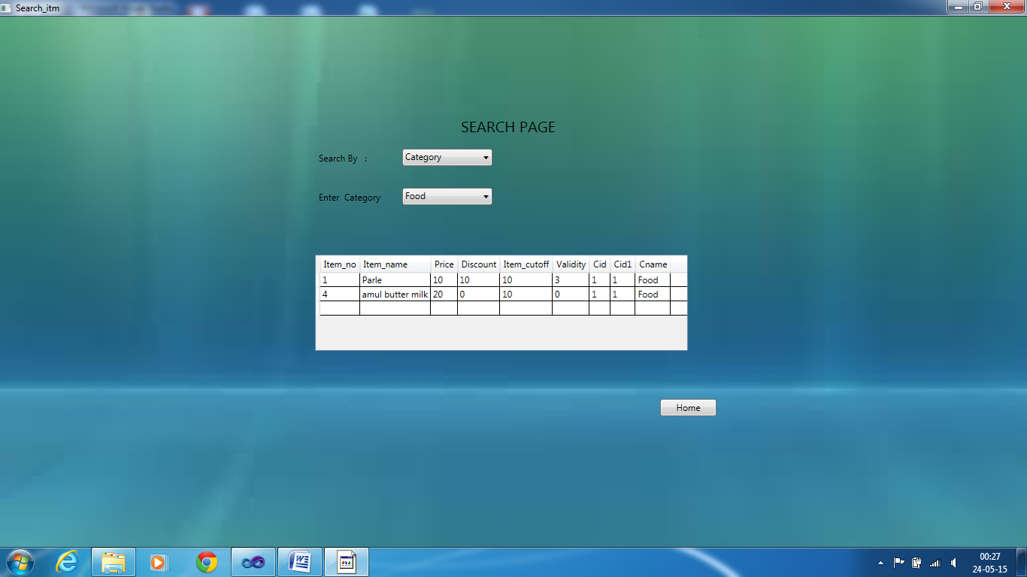

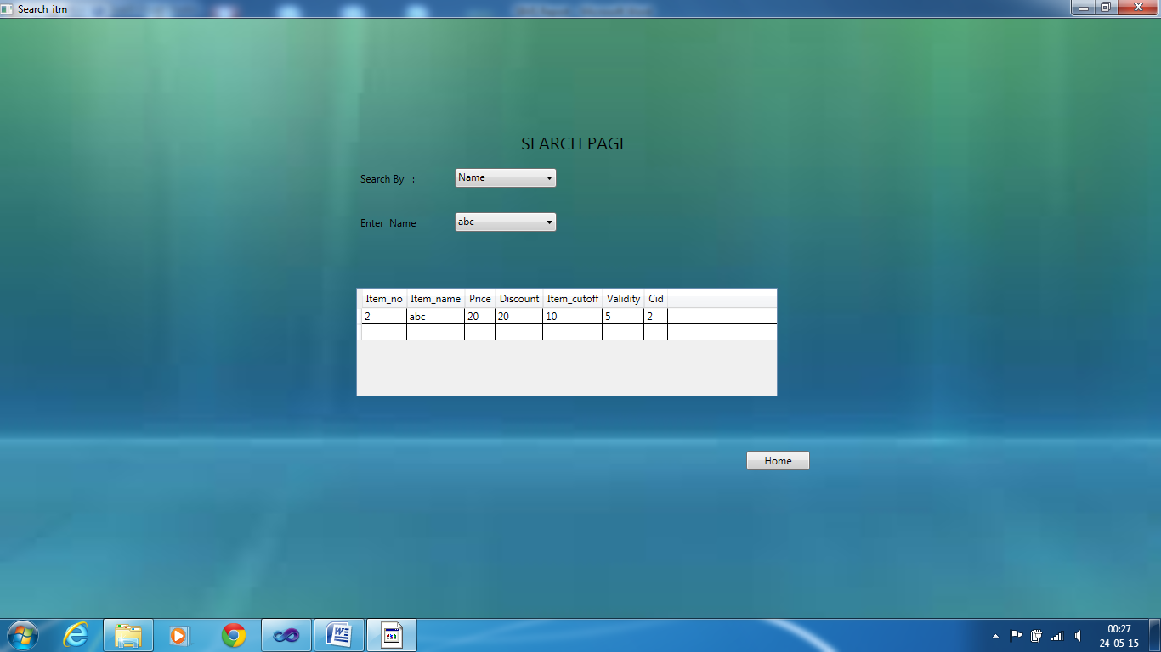

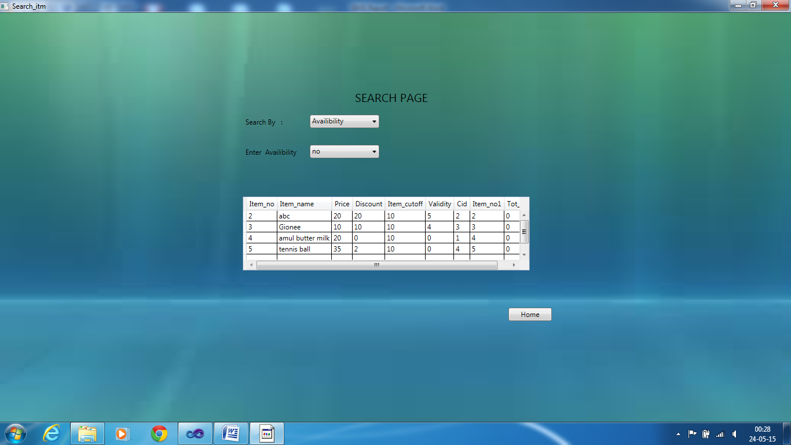

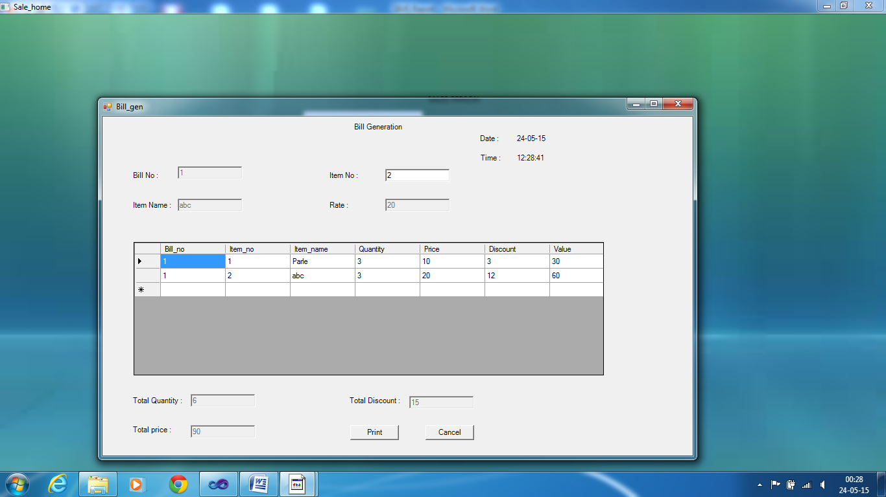

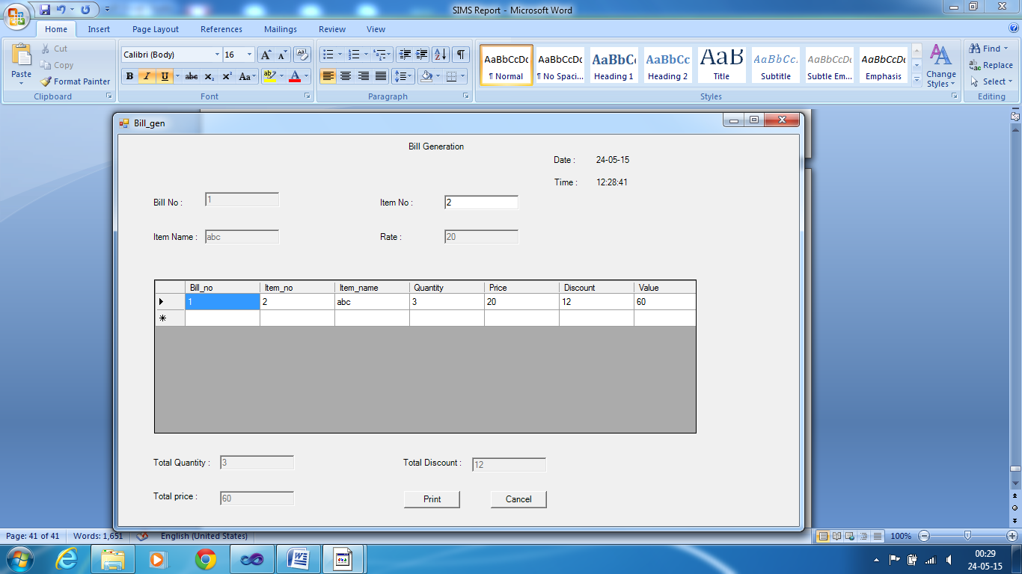

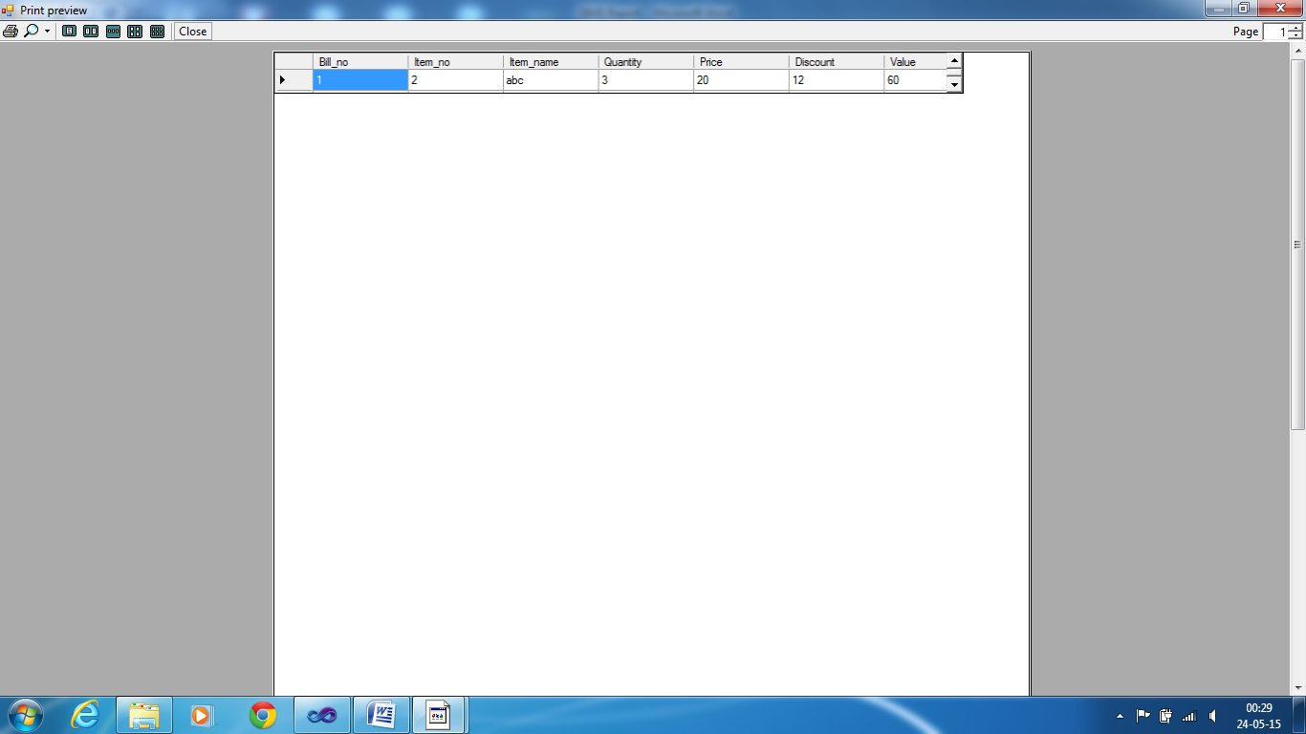

*SALES MANAGER PAGE AND SUB PAGES*

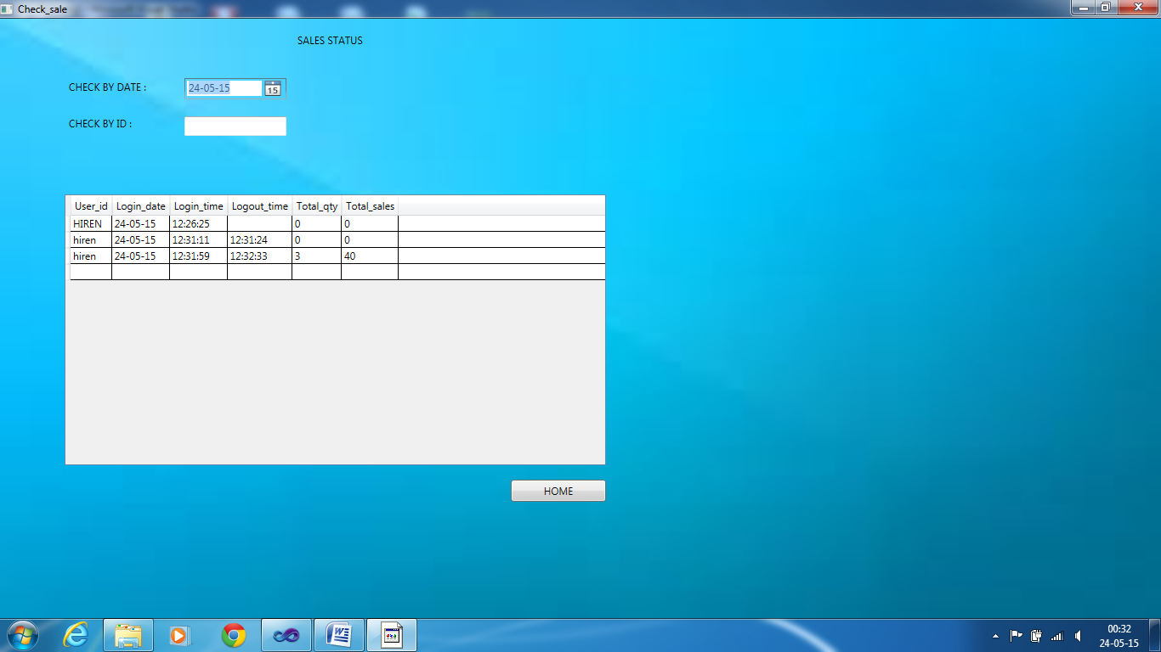

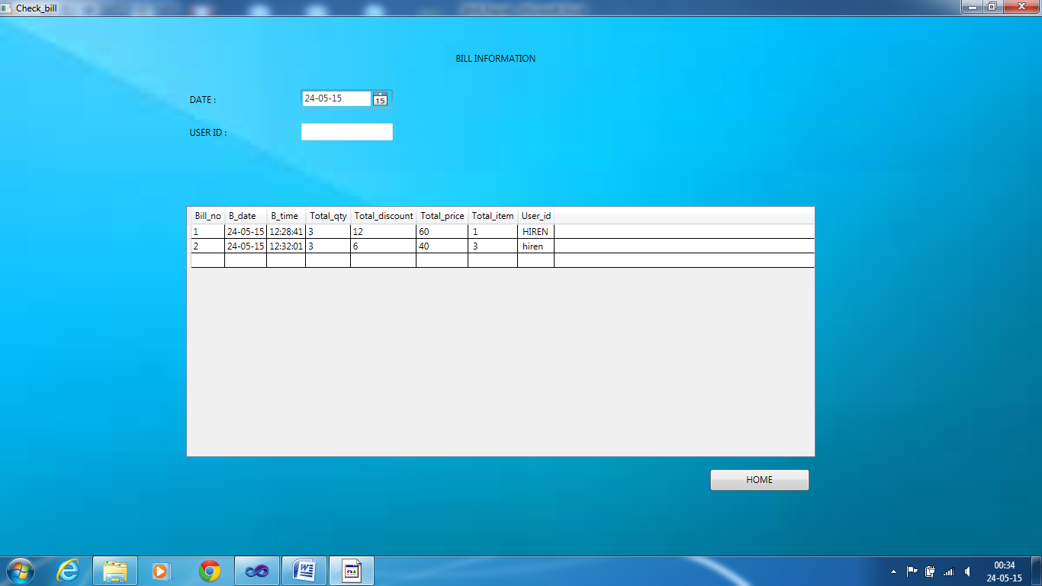

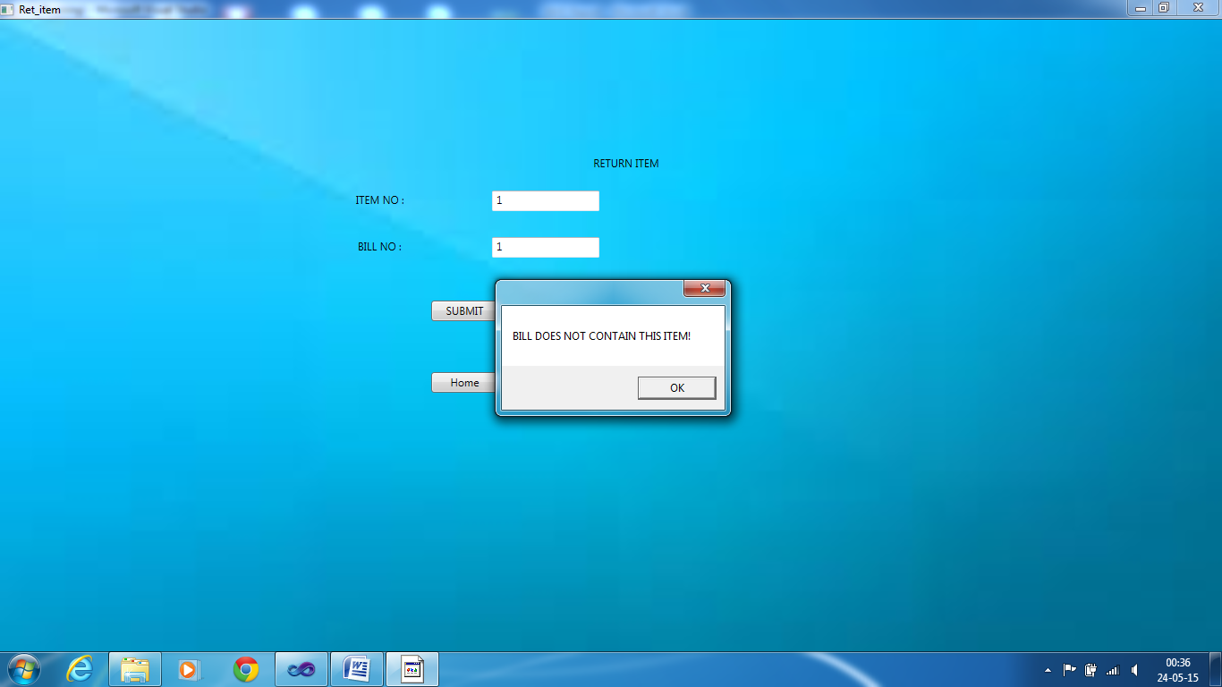

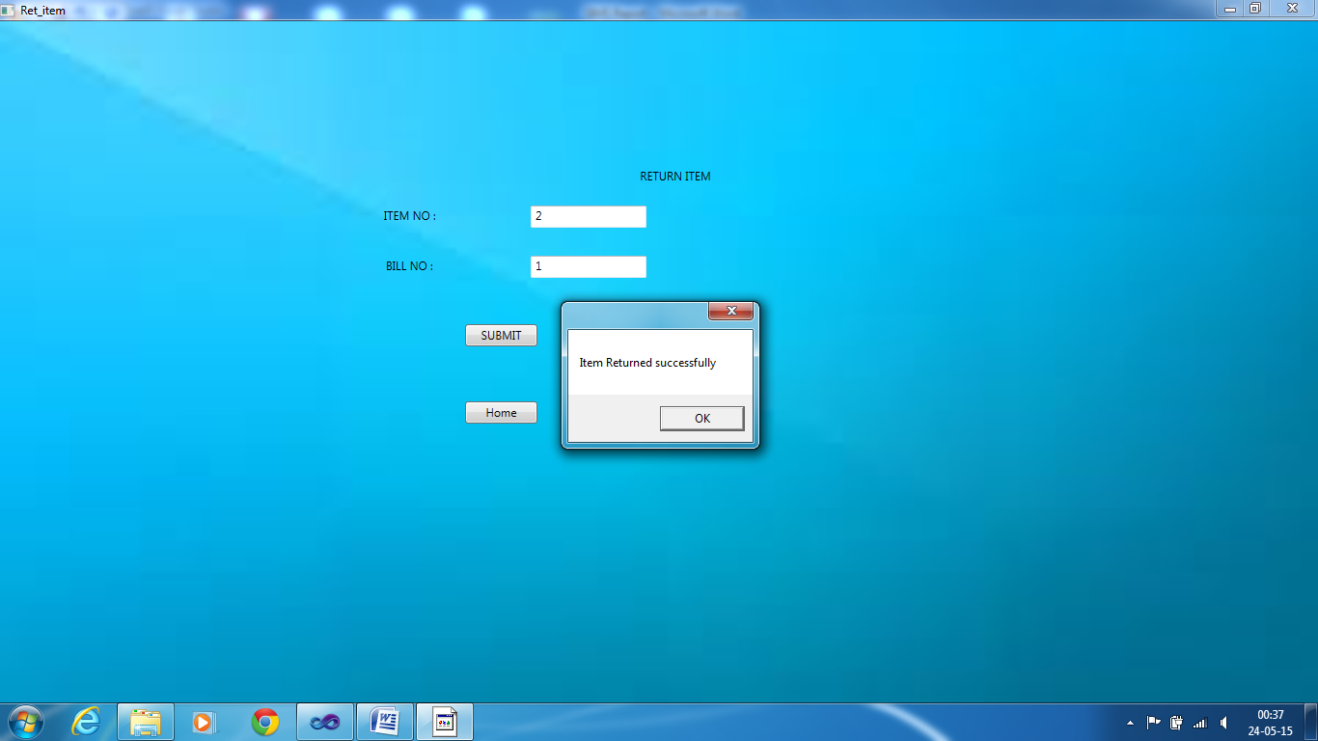

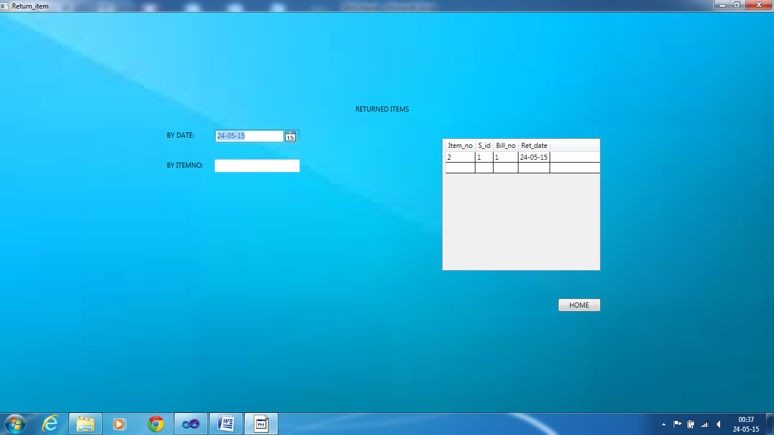

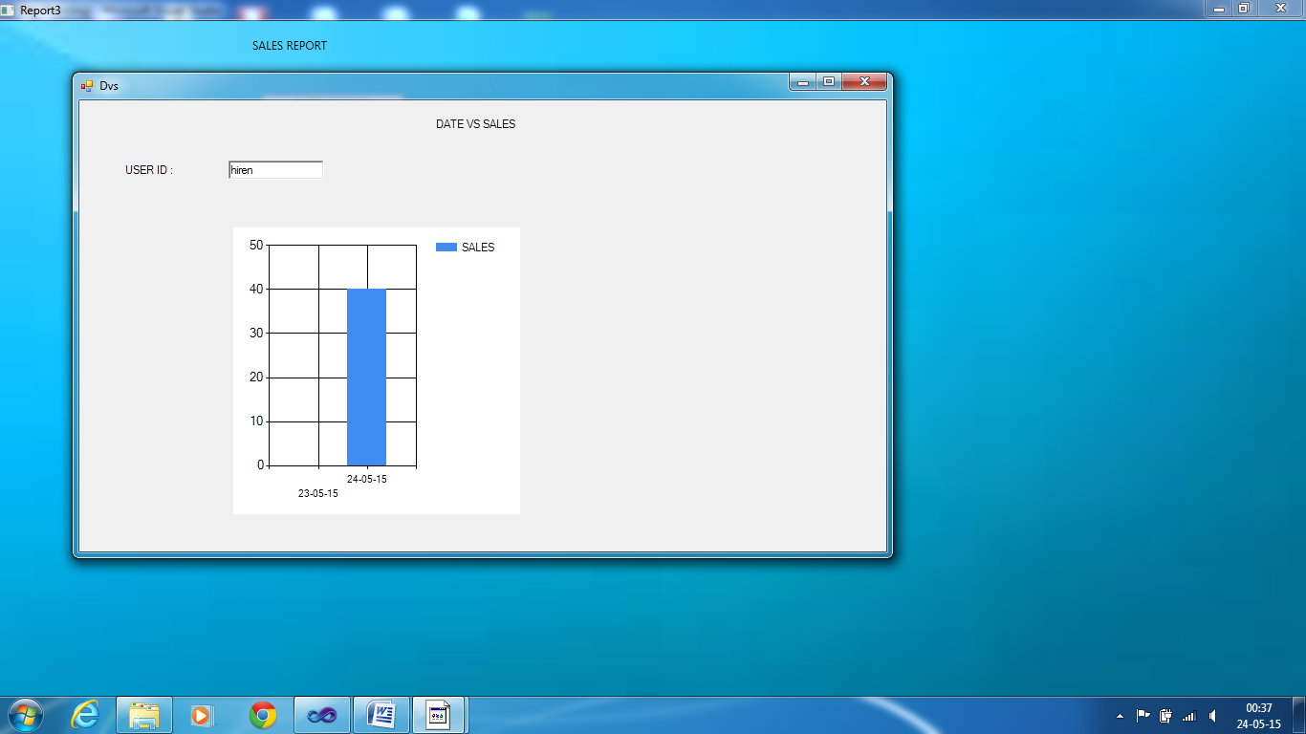

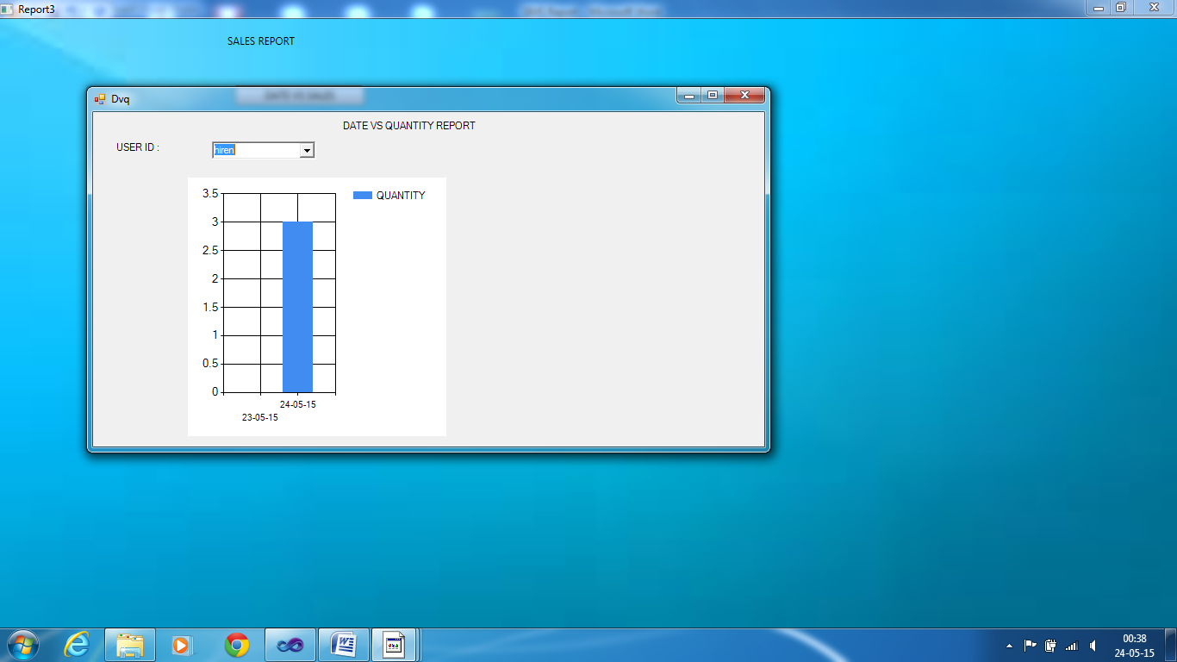

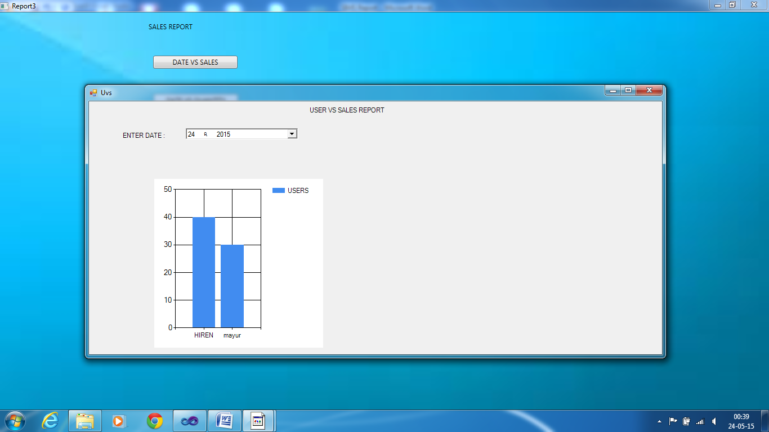

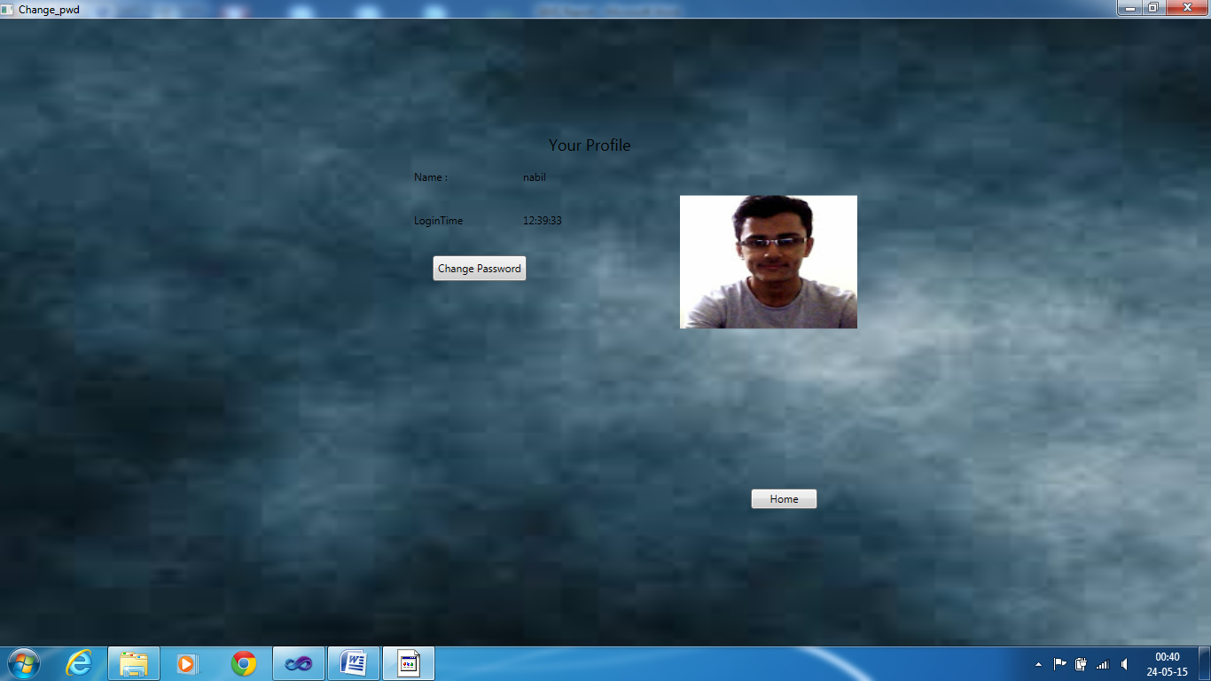

*10. FUTURE EXPACTATIONS*

* This is stand alone system, for actual use of the database , management can have distributed architecture in which database is on server and other terminal have access to it.
* As input for bill generation process here barcode scanner can be used.